**Clash Royale Balance Update**

[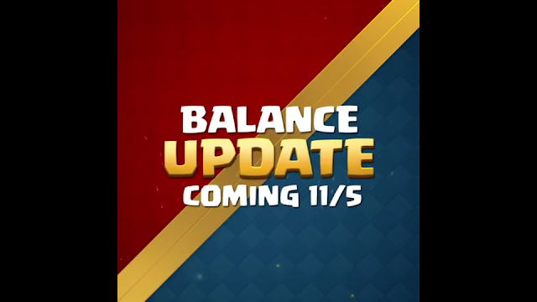](https://2.bp.blogspot.com/-t9lCqvotysQ/W9_3yH-XP7I/AAAAAAAAAfw/qHfVgXzm6PIqmNaViNflAJfampF87Bg0QCLcBGAs/s1600/New%2BBalance%2BUpdate%2B115.png)

In **November** balance update, **10 cards are getting** [**nerf**](https://english.stackexchange.com/questions/4221/etymology-of-buff-and-nerf-as-used-in-video-game-slang) **and** [**buff**](https://english.stackexchange.com/questions/4221/etymology-of-buff-and-nerf-as-used-in-video-game-slang). But most of the cards getting nerf. From ten cards, **6 is getting nerf** and **3 cards are getting buff**. Another card is getting buff but it's getting buff **as players vote**. In this article, you will get a proper idea about this balance update and also these cards interactions with other cards after the update.

**Nerfed Cards**

[](https://1.bp.blogspot.com/-xdYOcneN4So/W9_3-9KSewI/AAAAAAAAAf0/ueLCdPlMbgY_ejiQ19TrtC1i_QgJRpfuwCLcBGAs/s1600/Nerf.png)

**Royal Ghost**

[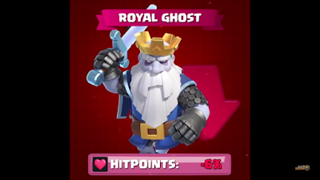](https://1.bp.blogspot.com/-jSo7KBALg5A/W9_4KstwmdI/AAAAAAAAAf8/5JKM38ZnYW4C9dmAYxWIdjHy1MZ9G8g_ACLcBGAs/s1600/Royal%2BGhost.png)

It is one of the most aggressive cards in the tournament standards. Its win percentage is so much high over other cards. That's why Supercell decided to nerf it. **Its hitpoint reduced by 6%**. It means for now Royal Ghost will survive little bit less time in the arena. Now it will die faster. Many troops will have to hit it one less time. That's a positive update for the players who are so much annoyed by Royal Ghost.

**Magic Archer**

[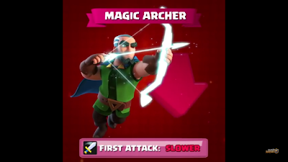](https://4.bp.blogspot.com/-Z1jPkT1KCso/W9_4bExkTII/AAAAAAAAAgI/eyUSY-pdB6AzeRMNuUYn0BFHCzss1ugkQCLcBGAs/s1600/Magic%2BArcher.png)

Another legendary card which is going to be nerfed in this update. Magic Archer was used in the deck which will bait Fireball. Also, it is precious for its huge range of cover like a Princess. But now Supercell nerfing its first attack speed. Now it's **first attack will be slower than before**.

**Royal Hogs**

[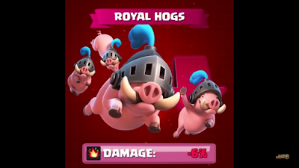](https://3.bp.blogspot.com/-1-cihMeHipw/W9_41VfdfgI/AAAAAAAAAgU/ORds5027kqgd_pdLOjReE4waklLGciJowCLcBGAs/s1600/Royal%2BHogs.png)

1) Royal Hogs are recently released card of Clash Royale. That's why Supercell trying to balance it for the betterness of the players. Royal Hogs are four hogs without a rider. They come straight to the tower to deal more damage. From the releasing of the card, it was so much annoying for me. I think also it was annoying to the other players. **Supercell decreased its damage by 6%**. From now in, they won't deal that much damage to the tower.

[](https://4.bp.blogspot.com/-4xiC3IQA0h8/W9_5Ijnht5I/AAAAAAAAAgc/E4r8LIb0kD4QTFSP2McnCZDtYQUpE93uACLcBGAs/s1600/mass%2Bupdate%2Bfor%2BRoyal%2BHogs.png)

2) Another balance update for Royal Hogs. **It's a mass update for Royal Hogs**. Before this update, Royal Hogs could push other units easily like Hog Rider. Their mass was the same as Hog Rider. But from now on they won't. Their mass is reduced from 4 to 2. Now their mass action will perform as goblins.

**Giant**

[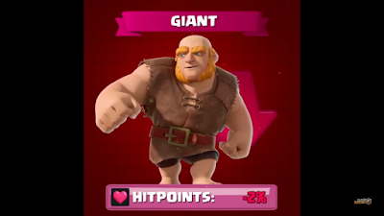](https://3.bp.blogspot.com/-EsEPj_U_EZA/W9_5kch4Y6I/AAAAAAAAAgk/wOeYrgXPQHUn64OzkZ_E51tHtFNIpVMSQCLcBGAs/s1600/Giant.png)

Giant is the most used tank card in the game. That's why Supercell is trying to give it a nerf. It gets hit points nerfed. **Giants hitpoint is reducing by 2%**. For this, it will take less time for the queen tower to kill the Giant. This interaction will also work with other cards. They will also make one less hit to kill the Giant.

**Tombstone**

[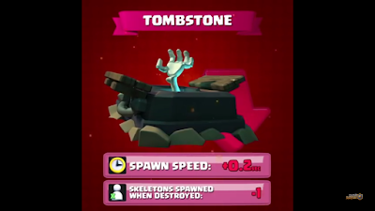](https://3.bp.blogspot.com/-tcLSZhka2zE/W9_51Boc3lI/AAAAAAAAAgs/xje7UIFTE_U00jttvefjqVP7Kl73m-lsgCLcBGAs/s1600/Tombstone.png)

1) Tombstone getting a nerf for its vast use in Lavaloon deck. From this update, **it will spawn one less skeleton when it is destroyed**.

2) It's getting another nerf. Which is its skeleton spawn time. For **reducing its skeleton spawn speed 0.2sec**, it will also spawn one less skeleton when Tombstone is not destroyed.

**Canon Cart**

[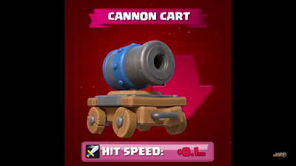](https://3.bp.blogspot.com/-3xvoHA_PKFc/W9_6EMbeK6I/AAAAAAAAAgw/v8O-K2hIIWUvpXHAyKjxnUcx977hkqdFQCLcBGAs/s1600/Canon%2BCart.png)

Canon cart was dominating in Graveyard deck. Which was in the knowledge of Supercell. That's why they are giving it a nerf. It's hit speed is nerfing. **Canon Cart's hit speed is increasing by 0.1sec**. For increasing its hit speed it will take more time to attack. So it's a nerf for this card.

**Buffed cards**

[](https://2.bp.blogspot.com/-kl7MCIc_TaE/W9_6aLnG3MI/AAAAAAAAAg8/EIEq0m_MHwAOkBS1hKFa0Hisfh6C64ZGwCLcBGAs/s1600/Buff.png)

**Inferno Tower**

[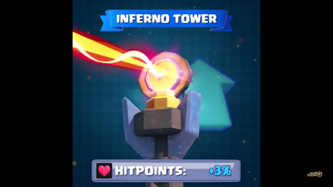](https://1.bp.blogspot.com/-ofqkbpvbxr8/W9_6l9yZc2I/AAAAAAAAAhA/sMB9cBQz8eIDimHxawOGv4FO0b47rJGGQCLcBGAs/s1600/Inferno%2BTower.png)

Inferno Tower is considered one of the best building card. Which can defend any tank and any card easily.  Now it will be more dangerous. Because **it's hit points is increasing by 3%**. Now it will be in the arena for more time.

**Skeleton Barrel**

[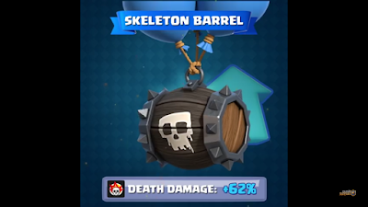](https://3.bp.blogspot.com/-5Gwn-Q4e5BE/W9_62UgtGcI/AAAAAAAAAhM/2uVVjU1jQrAA1PQ_feNiADrvMo_s8wf_wCLcBGAs/s1600/Skeleton%2BBarrel.png)

This card is receiving a huge update. I have never seen this kind of buff to any card. It is getting 62% death damage increase. For that, it will kill skeletons, goblins when the barrel is broken. It's a huge plus point for skeleton barrel users.

**Mega Knight**

[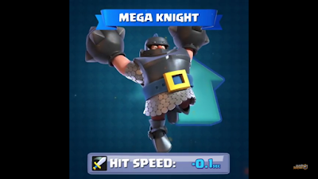](https://1.bp.blogspot.com/-CvMnal79R6g/W9_7IaIVQOI/AAAAAAAAAhU/AklI9-EKx3cA4QrpLUPyIikN25-Zn4nVwCLcBGAs/s1600/Mega%2BKnight.png)

This card is a favorite of many players. This legendary card can be used as defense and offense both. In this update, it is receiving a decrease of its hit speed. It's not a nerf. Decreasing of hit speed means from now on it will take less time to attack. **It's attacking speed is boosted by 0.1sec**.

**Players Choice**

[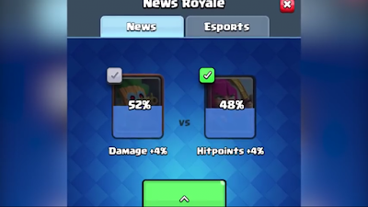](https://2.bp.blogspot.com/-v0zWQi8TCs4/W9_7ay2HOUI/AAAAAAAAAhc/r_dDFYgBbTkaZkaqY0b47_o7hVAHbRqsQCLcBGAs/s1600/Players%2BChoice%2Bvote.png)

Supercell's previous players choice card update was Ice Wizard on the last [Balance Update 10/1](https://a1lifebeststyle.blogspot.com/2018/10/balance-update-101.html). Like the last update, they also did a voting in this update between Archers and Dart Goblin. Guess who won??

[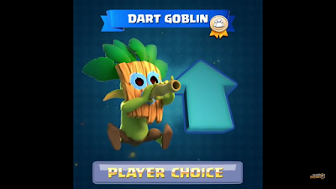](https://2.bp.blogspot.com/-JlxEF6WMiOA/W9_7qCFs6-I/AAAAAAAAAhg/9m5MZoOrlnwHopG7bGASBVNVIWthbinmgCLcBGAs/s1600/Dart%2BGoblin.png)

It's Dart Goblin. This card won the voting as players vote in the game. Now it is getting a buff.

**Dart Goblin**

[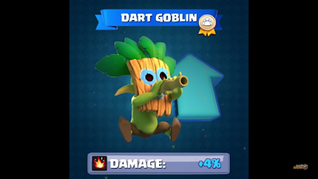](https://1.bp.blogspot.com/-Z8QvIVlJbRQ/W9_71naofuI/AAAAAAAAAho/ewBQT5WU9EM422PQBhx8jgqAqv6LMn00wCLcBGAs/s1600/Dart%2BGoblin%2B1.png)

Its damage is increased by 4%. For this, it will deal more damage to the cards. And also this card will get some extra hit in the tower. Which is a huge buff for Dart Goblin.

**Conclusion**

This update will not affect your game if you play smart. For playing smart you must know [How To Build A Good Deck In Clash Royale](https://a1lifebeststyle.blogspot.com/2018/10/how-to-build-good-deck-in-cr-for.html). If you do so and play in your comfort zone then you will find the positive result of this update. Or you can practice in [Clash Royale Private Server](https://a1lifebeststyle.blogspot.com/2018/10/clash-royale-private-server.html) for earning more skill.

Hope that you got a proper idea about this update. If you do, please visit our website for other valuable information about [Clash Royale](https://clashroyale.com/).